Purchasing procedure at University of Cambridge
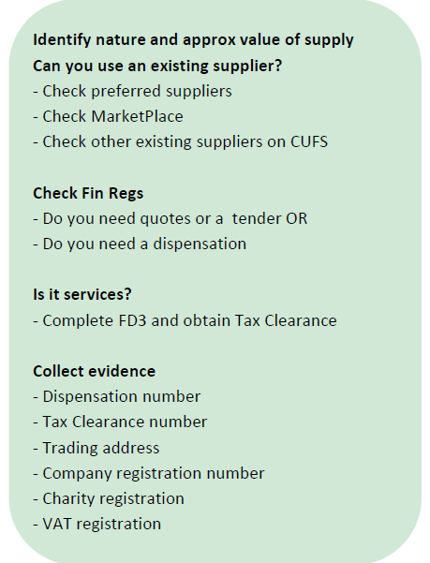
- Modern Slavery Act statement signed (see the form below)
- Quotation addressed to:
University of Cambridge,
Faculty of Music, 11 West Road, Cambridge CB3 9DP
On headed paper with the supplier’s details:
- registered name,
- address,
- number,
- charity number,
- VAT registration number,
- Contact details (www, email, phone number),
- service/goods description,
- price,
- VAT rate
- Signed service agreement
- invoice

Schedule 1 - Competition Procedures
If total contract value equals or more than £1,000, obtain three quotations from various potential suppliers. If not possible, obtain dispensation from normal competition requirements using online form:
https://www.procurement.admin.cam.ac.uk/information/dispensation

Include the supplier’s bank details, full name, full address, contact details (email) and service details. Indicate any extra costs (travel/material) and then they can be included on the invoice together with the fee.

To obtain Tax Clearance Number for a service provider, fill the form:
https://www.finance.admin.cam.ac.uk/fd3-employment-status-form

Elements to include on invoices from suppliers
- Addressed to: University of Cambridge, Faculty of Music, 11 West Road, Cambridge, CB3 9DP
- Supplier’s registered name
- Supplier’s registered number
- Supplier’s full address
- Supplier’s VAT registration number
- Supplier’s bank details
- Invoice unique number
- Invoice date
- Purchase Order number (issued by Faculty of Music, to issue a PO firstly the supplier must be set up)
- Description of the service/goods provided
- Net cost
- Number of items/services
- Total net amount
- VAT rate
- VAT amount for each rate
- Gross amount

Simple invoice template:

VAT
CU’s VAT registration number is GB 823 8476 09.
Purchasing goods from outside the EC - When buying goods from countries outside the EC VAT will not be charged by the supplier. However, both VAT and duty will be applied when the item comes through Customs at the port of entry, if applicable, and is usually charged via your import agent.
Purchasing services from outside the UK - The overseas supplier should not charge VAT on its invoice. This is not as beneficial as it might seem because the University is required by law to charge itself VAT at the UK standard rate of 20% (if the services would have been subject to standard rate VAT if purchased in the UK). This puts the University in the same position as if we had received the supply from a UK supplier rather than from one outside the UK.
Provide the University's VAT number (GB 823 8476 09) to demonstrate you are a business customer or the supplier may charge you VAT at the rate applicable in their country.

