VISITING STUDENT APPLICATION
v. 2023_01
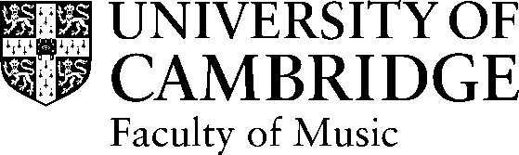 | VISITING STUDENT APPLICATION  v. 2023_01

PERSONAL DETAILS
Forename(s) : | Surname : | Title :
Current address : | Contact details :  (1) Daytime telephone:  (2) Mobile:  (3) E-mail address:
Date of Birth : | Nationality :
Are you currently taking a course of postgraduate study? Yes No
If so, please give details :
Course title : | PhD / Masters (Delete as appropriate)
Name of institution : | Name of Faculty or Department :
Do you hold a University teaching position? Yes No
If so, please give details :

Job title : | Name of institution :
Reason for applying for Visitor status in the Faculty of Music :

Start date of your stay in Cambridge : | End date of your stay in Cambridge :

REFERENCES

First Referee :
Name and title :
Position :
Address :
Telephone number :
E-mail address :

Second Referee :
Name and title :
Position :
Address :
Telephone number :
E-mail address :

Academic Sponsor:
(Cambridge Academic Staff member)

Please give details of the appropriate financial arrangements through which you will pay your fees and support your stay:

NOTES FOR APPLICANTS

Please note: you must ask your referees to email their references to you, and it is your responsibility to attach these references to your application.

- Applications must be sent by email to the Faculty of Music Visitor Coordinator (admin@mus.cam.ac.uk)
- Applications will be considered in February, May and October and should reach the Visitor Coordinator by the first day of the previous month.
- Your application form must be accompanied by:

- An English Language Test certificate valid within the last 2 years
NB – if you do not have this available, you should write a short statement as to why you should be exempt, this can include details of previous English Language tests taken or previous qualifications obtained in English
- a summary curriculum vitae (of no more than 4 sides of A4)
- a .jpeg image of yourself
- a structured outline of your research interests (of one side of A4)
- a sample piece of work- up to 10,000 words (i.e. a recent piece of course work relating to the work you intend to pursue in Cambridge)
- a letter of introduction from your home institution which must confirm how your research here relates to your ongoing studies overseas
- two academic references

Incomplete applications cannot be processed.

This form must be returned not less than two months before the date of intended arrival, OR more than 18 months before your planned arrival date in Cambridge.

